**University of Central Punjab**

Assignment # 2

**Time & Date Deadline**: 22nd April, 2022 11:59 PM

**Course**: Programming Fundamentals (PF)

# Submission Instructions:

1. You have to submit 1 zip file containing:
   * MS word document containing C++ programs with screen shot of console
   * .cpp file of the program and input files where required
2. You have to upload your assignments on CMS.
3. Plagiarism is not acceptable. If someone’s assignment is plagiarized, that student will be given F straight away, so beware.
4. The deadline for this assignment is **April 22nd, 2022, 11:59 pm**. No late submission will be accepted.

**Learning Objectives:** Demonstrate knowledge of functions, file handling and pointers in programming(C++).

**Task 1:**

A car park charges a £2.00 minimum fee to park for up to 3 hours, and an additional £0.50 for each hour or part hour in excess of three hours. The maximum charge for any given 24-hour period is £10.00. Assume that no car parks for more than 24 hours at a time.

Write a C++ functions-based program that will calculate and print the parking charges for each of 3 customers who parked their car in the car park yesterday. The program should accept as input the number of hours that each customer was parked, and saves the results in a neat tabular form in a file, along with the total receipts from the three customers:

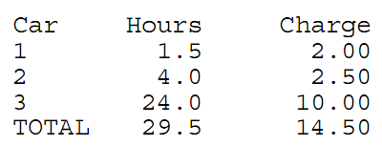

**NOTE:** Your program should use the separate function for each specified task.

**Task 2:**

Write a function ***rotate*** that takes two integer ***a*** and ***pos*** as parameters and rotate ***pos*** digits of ***a***. For example, given **a** = 12345 and **pos**=3, after execution of function **rotate** new value of ***a*** would be 34512.

Your function should work for the following driver function

|  |
| --- |
| int main( ){  int a=12345;  rotate(a,2);  cout<<a; ***//should output rotated value of a i.e. 45123***  } |

**Task 3:**

Write 4 different functions to perform the operations as explained below. These functions will receive only 2 variables and return nothing but perform the following tasks:

**Main =>** call all 5 functions one by one, by passing 2 variables.

**InvisibleSwap =>** receive 2 integers, swap them, but this swap will not visible in main

**visibleSwap =>** receive 2 integers, swap them, but this swap will visible in main

**InvisibleSwapByPointer =>** receive 2 integer pointers, swap their values, but this swap will not visible in main.

**visibleSwapByPointer =>** receive 2 integer pointers, swap their values, but this swap will visible in main.

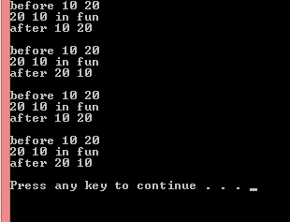

🡨--------------------------------------------------------------------------------------------------🡪

***“When you are not practicing, remember somewhere someone is practicing, and when you meet him, he will win.”***